Quick Start Tutorial: How to create a basic Negotiation Agent

In this tutorial you will learn how to create your own basic negotiation agent. To get you started, we will walk through the code of the example agent, SimpleAgent.java.

In this tutorial we assume that you are familiar with programming in Java. In case you are not familiar with Java, please consult the following tutorial: http://www.oracle.com/technetwork/java/javase/documentation/index.html. The Java API definitions can be found here as well.

In a Java editor, such as Eclipse or Netbeans, create a new Java project.
Add negotiationsimulator.jar as an external library.
Create a new class with a distinct name (ex. YourAgent) as a subclass to extend the superclass, negotiator.Agent.
The table below shows the most important fields and methods of this class. For more information, please refer to the javadoc of Genius.
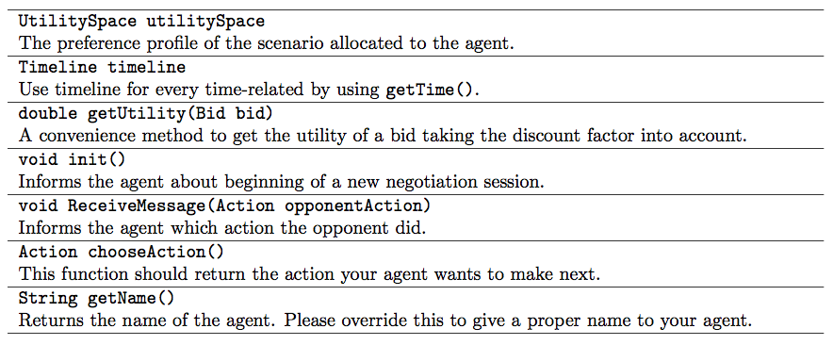
To implement your agent, you need to override the three methods:
- init
- ReceiveMessage
- chooseAction

Let’s take a look how this is done in SimpleAgent.java, which is provided in the Agent Example folder.
Initialize Negotiation:
init is called when a next session starts with the same opponent:
public void init()
{
MINIMUM_BID_UTILITY = utilitySpace.getReservationValueUndiscounted();
}

The minimum bid utility is defined:

private static double MINIMUM_BID_UTILITY = 0.0;

Receiving the Opponent’s action:
The ReceiveMessage(Action opponentAction) informs you that the opponent just performed the action opponentAction. The opponentAction may be null if you are the first to place a bid or an Offer, Accept or EndNegotiation action. The chooseAction() asks you to specify an Action to send to the opponent.
In the SimpleAgent code, the SimpleAgent stores the opponent’s action to use when choosing an action:
public void ReceiveMessage(Action opponentAction) { actionOfPartner = opponentAction;
}
The private variable, actionOfPartner, is initially set to null:
private Action actionOfPartner=null;
Choosing action:
For SimpleAgent, the chooseAction code is wrapped in a try-catch block, because if our code would accidentally contain a bug we still want to return a good action (failure to do so is a protocol error and results in a utility of 0.0).
The sample code below works as follows: If we are the first to place a bid, we place a random bid with sufficient utility (see the .java file for the details). Else, we determine the probability to accept the bid, depending on the utility of the offered bid and the remaining time. Finally, we randomly accept or pose a new random bid.
While this strategy works, in general it will lead to suboptimal results as it does not take the opponent into account. More advanced agents try to model the opponent’s strategy or preference profile.
public Action chooseAction () {
Action action = null;
try {
if (actionOfPartner == null) {
action = chooseRandomBidAction ();
}
if (actionOfPartner instanceof Offer) {
Bid partnerBid = ((Offer) actionOfPartner).getBid();
double offeredUtilFromOpponent = getUtility(partnerBid);
// get current time
double time = timeline.getTime();
action = chooseRandomBidAction ();

Bid myBid = ((Offer) action).getBid();
double myOfferedUtil = getUtility(myBid);

// accept under certain circumstances
if (isAcceptable(offeredUtilFromOpponent ,myOfferedUtil ,time)) {
action = new Accept(getAgentID());
}
}
} catch (Exception e ) {
e.printStackTrace();
action = new Accept(getAgentID()); // best guess if things go wrong.
}
return action;
}

The private variable isAcceptable:

private boolean isAcceptable(double offeredUtilFromOpponent, double myOfferedUtil, double time) throws Exception
{
double P = Paccept(offeredUtilFromOpponent,time);
if (P > Math.random())
return true;
return false;
}

The private method Paccept:

double Paccept(double u, double t1) throws Exception
{
double t=t1*t1*t1; // steeper increase when deadline approaches.
if (u<0 || u>1.05) throw new Exception("utility "+u+" outside [0,1]");
// normalization may be slightly off, therefore we have a broad boundary up to 1.05
if (t<0 || t>1) throw new Exception("time "+t+" outside [0,1]");
if (u>1.) u=1;
if (t==0.5) return u;
return (u - 2.*u*t + 2.*(-1. + t + Math.sqrt(sq(-1. + t) + u*(-1. + 2*t))))/(-1. + 2*t);
}

Private method:

double sq(double x) { return x*x; }

The private method:

private Action chooseRandomBidAction()
{
Bid nextBid=null ;
try { nextBid = getRandomBid(); }
catch (Exception e) { System.out.println("Problem with received bid:"+e.getMessage()+". Cancelling bidding"); }
if (nextBid == null) return (new Accept(getAgentID()));
return (new Offer(getAgentID(), nextBid));
}

The private method:

private Bid getRandomBid() throws Exception{
HashMap<Integer, Value> values = new HashMap<Integer, Value>(); // pairs <issuenumber,chosen value string>
ArrayList<Issue> issues=utilitySpace.getDomain().getIssues();
Random randomnr= new Random();

// create a random bid with utility>MINIMUM_BID_UTIL.
// note that this may never succeed if you set MINIMUM too high!!!
// in that case we will search for a bid till the time is up (3 minutes)
// but this is just a simple agent.
Bid bid=null;
do
{
for(Issue lIssue:issues)
{
switch(lIssue.getType()) {
case DISCRETE:
IssueDiscrete lIssueDiscrete = (IssueDiscrete)lIssue;
int optionIndex=randomnr.nextInt(lIssueDiscrete.getNumberOfValues());
values.put(lIssue.getNumber(), lIssueDiscrete.getValue(optionIndex));
break;
case REAL:
IssueReal lIssueReal = (IssueReal)lIssue;
int optionInd = randomnr.nextInt(lIssueReal.getNumberOfDiscretizationSteps()-1);
values.put(lIssueReal.getNumber(), new ValueReal(lIssueReal.getLowerBound() + (lIssueReal.getUpperBound()-lIssueReal.getLowerBound())*(double)(optionInd)/(double)(lIssueReal.getNumberOfDiscretizationSteps())));
break;
case INTEGER:
IssueInteger lIssueInteger = (IssueInteger)lIssue;
int optionIndex2 = lIssueInteger.getLowerBound() + randomnr.nextInt(lIssueInteger.getUpperBound()-lIssueInteger.getLowerBound());
values.put(lIssueInteger.getNumber(), new ValueInteger(optionIndex2));
break;
default: throw new Exception("issue type "+lIssue.getType()+" not supported by SimpleAgent2");
}
}
bid=new Bid(utilitySpace.getDomain(),values);
} while (getUtility(bid) < MINIMUM_BID_UTILITY);

return bid;
}

